Using Crowdsourcing to Provide QoS for Mobile Cloud Computing

Assignment-II

Submitted by

Name: Tushar Jain

SAP ID: 500067385

Roll No: R110218173

Subject: Object Oriented Programming

Program: B.Tech CSE-CCVT

To

Prakash G.L.

Assistant Professor (SG)

Department of Virtualization

SCHOOL OF COMPUTER SCIENCE AND ENGINEERING

Department of Virtualization

University of Petroleum and Energy Studies

Bidholi, Via PremNagar

Dehradun, Uttarakhand – 248007

2019

**Abstract:** Quality of cloud service (QoS) is one of the crucial factors for the success of cloud providers in mobile cloud computing. Context-awareness is a popular method for automatic awareness of the mobile environment and choosing the most suitable cloud provider. Lack of context information may harm the user’s application rendering it useless. Thus, mobile devices need to be constantly aware of the environment and to test the performance of each cloud provider, which is inefficient and wastes energy. Crowdsourcing is a considerable technology to discover and select cloud services in order to provide intelligent, efficient, and stable discovering of services for mobile users based on group choice. Crowdsourcing-based QoS supports mobile cloud service framework that fulfills mobile users’ satisfaction by sensing their context information and providing appropriate services to each of the users. Based on user’s activity context, social context, service context, and device context, our framework dynamically adapts cloud service for the requests in different kinds of scenarios. The context-awareness based management approach efficiency achieves a reliable cloud service supported platform to supply the Quality of Service on mobile device.

**1 INTRODUCTION**

Mobile cloud computing is used to deliver applications to mobile devices. These mobile apps can be deployed remotely using Speed and flexibility and development tools. One prolific example is the cloMobile where cloud applications can be built or revised quickly using cloud services. They can be delivered to many different devices with different operating systems, computing tasks and data storage. Thus, users can access applications that could not otherwise be supported.

**1.1 Key features**

* Facilitates the quick development of mobile apps.
* Supports a variety of development approaches and devices.
* Improves reliability with information backed up and stored in the cloud.
* Applications use fewer device resources because they are cloud-supported.

With the proliferation of increasingly powerful mobile devices, mobile users can collaboratively form a mobile cloud to provide effective services, such as data collecting, processing, and computing. With this mobile cloud, mobile crowdsourcing has emerged as an emerging service paradigm that can enable mobile users to take over the outsourced tasks. By outsourcing the sensing capabilities of mobile devices and integrating human intelligence and machine-computation, mobile crowdsourcing has the potential to revolutionize the approach of data collecting and processing.

**1.2 Key issues**

* 1. QoS is affected due to the diversity of kinds of services and the complexity of the mobile environment. They often lack the capabilities or knowledge of service providers and network environments in the different places. They do not know how to choose the suitable cloud service on their own. The device needs to be continuously aware of the environments when they move to a new place which causes battery issues.
  2. Mobile computing environments are complex and unpredictable. The presence of lack of knowledge of understanding environments and inefficient discovering services harms the users’ quality of experience (QoE) in the service thus rendering it useless.
  3. The user’s satisfaction needs to be taken care of as the system choses any type of service. The relationship between user’s satisfaction, crowdsourcing of decider, and complexity of awareness should be enhanced.

**1.3 Application**

In the last five years mobile devices have become sensor and information hubs in our daily life. By integrating mobile computing and crowdsourcing, some emerging applications have shown the potential to achieve highly efficient and cost effective data computation, collection, and processing services

Mobile Crowdcomputing: Mobile Crowdcomputing is used to outsource data computation tasks to mobile users. The mobile users who participate in the outsourced tasks can locally execute these tasks or offload them to the cloud severs based on their own data and computation resources. Due to human intervention, mobile crowdcomputing can leverage human-intelligence to deal with the tasks that are more suitable for human evaluation than machine computation E.g. - entity resolution, image annotation, and sentiment analysis. Honeybee is a local-based mobile crowdcomputing application, in which face detection and photography tasks are outsourced to local mobile users. The mobile users use their mobile devices to run face detection algorithms and take specific photos, together with their personal evaluation. CrowdDB crowdsources the computing tasks in the form of querying and answering, based on the Amazon Mechanical Turk platform.

Mobile Crowdsensing: Data collection and processing, such as environment sensing and monitoring, generally require enormous technical efforts and significant economic resources. Mobile crowdsensing is used to outsource data collection and processing tasks to mobile users, who can perform data sensing with sensor-equipped mobile devices, and execute data processing by local computing or mobile cloud computing. By motivating mobile users’ participation, mobile crowdsensing can provide cost-efficient mobile cloud services for data collection and processing. SignalGuru is a local-based mobile crowdsensing application, utilizing smartphones to opportunistically detect current traffic signals and collaboratively exchange their detection information via an ad-hoc network. The smartphones can predict the future schedule of traffic signals based on the collection of exchanged information to guide the driving decision-making. Medusa is a mobile crowdsensing application that collects specific sensing data by outsourcing sensing tasks, including video documentation, auditioning, and road monitoring, to Internet-connected mobile users via secure-HTTP based wireless communication.

**1.4 Motivation**

The mobile users may have some issues such as congestion due to the limitation of wireless bandwidths, network disconnection, and the signal attenuation caused by mobile users’ mobility. To continue using cloud services, we need to reconfigure the system settings by hand for different mobile environments. Furthermore, lack of provider’s information is also a shortcoming to choose suitable cloud service. Context-awareness is an excellent solution to sense mobile environments and intelligently choose the best cloud service. In addition to crowdsourcing technology, we can achieve the goal to choose intelligently the best cloud service to provide QoS for mobile device. For that we need to know about the following topics

1.4.1 Macro Perspective: Quality of Provider

The service quality of a main provider refers to the capability of a provider. The capability of a provider includes the computing power and storage capacity. The higher the capability offered by a provider, the better the cloud service will be. Different providers will have different service quality for mobile users. A mobile user does not know each provider’s capability, so we need a central registration center to collect that information. Moreover, the mobile users may face complex network situations in a mobile cloud environment. They cause delays when users want to communicate with the cloud, so QoS is reduced significantly.

1.4.2 Micro Perspective: Quality of Environment

The same cloud service provider may perform different Quality of Service for a mobile user in different network. The network bandwidths are different and network latencies are also not the same. The service quality of a provider mainly depends on network bandwidth, network latency. The network bandwidth is influenced by what kind of wireless connection is used, how many people use it, and user’s mobility. So the service quality is related to multiple context information. The network latency reduces interactive performance even with good bandwidth. Therefore, the quality of a cloud service cannot just be observed from network environment, the network and cloud service providers need to be measured both.

**1.5 Contribution**

The key contributions of this work are summarized as follows:

* 1. Design a crowdsourcing platform to supply QoS for mobile cloud service.
  2. Propose a crowdsourcing-based server discovery schemes for choosing the optimal cloud service.
  3. Implement a prototype platform and evaluate the efficiency of crowdsourcing model with traditional schemes.

**2 RELATED WORKS**

1. D. Yao, C. Yu, H. Jin, and J. Zhou, “Energy efficient task scheduling in mobile cloud computing,” in Proc. 10th IFIP Int. Conf. Netw. Parallel Comput., Sep. 19–21, 2013, pp. 344– 355

In this research article, they have talked about how Cloud Computing can enhance the computing capability of mobile systems by oﬄoading. Transmitting large data to cloud consumes much more energy than processing data in mobile device, especially in a low bandwidth condition. In this article there is a proposal of an energy efficient strategy which focuses on reducing the amount of data transmission. This significantly increases the speed of the device since the computations would be reduced. The results show 99% accuracy but power consumption is still a debatable topic. While implementing the above solutions the disadvantage is the huge power consumption.

1. Y. Zhao and Q. Zhu, “Evaluation on crowdsourcing research: Current status and future direction,” Inform. Syst. Frontiers, vol. 16, no. 3, pp. 417–434, 2014.

This paper seeks to present a critical examination of the substrate of crowdsourcing research by surveying the landscape of existing studies, including theoretical foundations, research methods, and research foci, and identifies several important research directions for IS scholars from three perspectives—the participant, organization, and system—and which warrant further study. This research contributes to the IS literature and provides insights for researchers, designers, policy-makers, and managers to better understand various issues in crowdsourcing systems and projects. Adapting crowdsourcing as a business strategy would be a very profitable business in the markets since it involves low cost investments. Although crowdsourcing works on the principle that ‘two heads are better than one’, sometimes a crowd can return a vast amount of noise that may not be relevant. Web 2.0 technologies are taken for granted and are not well addressed in the current crowdsourcing studies.

1. Y. Liu, J. Wu, Z. Zhang, and K. Xu, “Research achievements on the new generation internet architecture and protocols,” Sci. China Inform. Sci., vol. 56, no. 11, pp. 1–25, 2013.

Internet architecture, introduce the research achievements made under the new generation Internet architecture in detail, and propose our next-step research priorities and perspectives in the face of an increasing number of innovative Internet applications. In the process of developing the new generation Internet, these basic elements in the current Internet architectural design should be inherited and developed as far as possible. SAVI is the ﬁrst self-learning based algorithm that can maintain consistency of the state information between the authentication devices and the address assignment system, achieving precise universal synchronization without requiring the coordination mechanisms and coupling of the state machine under diﬀerent scenarios. Since it involves transparent network devices and protocol stacks, the advantage of the algorithm is security, ease of deployment and universal applicability. Meanwhile, faced with great technical challenges, we cannot truly resolve the problems in the Internet by revolutionary approaches; therefore, evolvable approaches have been proposed and persisted upon by us.

1. N. Fernando, S. W. Loke, and W. Rahayu, “Mobile cloud computing: A survey,” Future Gener. Comp. Syst., vol. 29, no. 1, pp. 84–106, 2013.

Despite increasing usage of mobile computing, exploiting its full potential is difficult due to its inherent problems such as resource scarcity, frequent disconnections, and mobility. Mobile cloud computing can address these problems by executing mobile applications on resource providers external to the mobile device. A wide range of potential mobile cloud applications have been recognized in the literature. These applications fall into different areas such as image processing, natural language processing, sharingGPS, sharing Internet access, sensor data applications, querying, crowd computing and multimedia search. While mobile devices connecting to remote cloud servers to run apps such as Google translate can connect while mobile, this depends on the user’s 3G connection. Even if the reception is sufficient, data costs and latency have a huge impaction these kinds of mobile cloud computing apps.

**3 PROBLEM DEFINITION**

**3.1 PROBLEMS**

One of the main challenges to mobile client users is quality of service (QoS) due to diversity of kind of services and complexity of mobile environment. Also, the users don't know how to choose suitable cloud service on their own. This lack of knowledge and insufficient discovery services harm user's Quality of Experience. Mobile users have issues such as congestion due to limited wireless bandwidths, network and signal attention caused by mobility of users. Mobile computing environment are complex and unpredictable. Mobility by user's create battery issue for them.

**3.2 OBJECTIVES**

1. Crowdsourcing is applied to mobile cloud users in order to provide QoS management for cloud service.
2. Another key objective is to reduce the cloud service discovery time than the local context awareness method.
3. It is introduced to solve massive parallel task.

**3.3 ASSUMPTIONS**

1. We assume that the mobile user can freely use different types of wireless network.
2. We assume that the user has proper internet connectivity and bandwidth as more the bandwidth more robust the transaction is.
3. We assume that Context inference is done properly by the provider.
4. We assume that the mobile devices have the capability to run the required application in background.

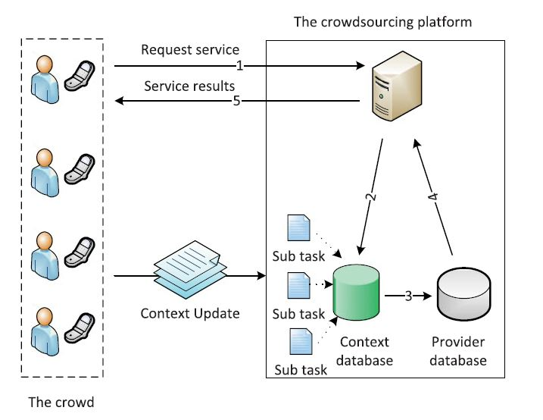**4 ALGORITHM**

Fig.1The workflow of the crowdsourcing based service discovery process.

**4.1 ALGORITHM DESCRIPTION**

Our purpose is to select an optimal combination service. The context-awareness based service discovery method can be viewed as two steps: context aware and QoS ranking. Given the information of cloud service providers and network providers (ISPs), Context Aware is collecting the QoS performance of each service combination. When the context collection is finished, QoS ranking searches for the optimal combination service by calculating QoS score QMS.

Algorithm 1. Context-Awareness Based Service Discovery

Input: W, ISP = (ISP1; ISP2; ... ISPM),

CLOUD = (CLOUD1; CLOUD2; ... CLOUDN)

Output: < i, j >

1: Initialization;

2: {Step 1} Context aware:

3: for ISPj in ISP do

4: for CLOUDi in CLOUD do

5: Test performance: (WSi, NSj)

6: Si,j = (WSi, NSj)

7: end for

8: end for

9: {Step 2} QoS ranking:

10: Snorm Normalize(S)

11: QMS = SnormW

12: < i, j > arg max < i, j > (QMS)

13: return < i, j >

The service discovery process can be described as a query for the most suitable result from gathering data. Each mobile user’s service usage update will be considered as a sub task to meet service discovery process. The service request contains two main parts: requestor’s information and service constraint. The description of the request can be denoted as:

Q = (User; Provider; Constraint) = {(CUM; CUL; CNT), (CPN; CPD), W}

The requestor’s information is the user context which is a condition for the service query. After the alternative services retrieved from the crowdsourcing database, the quality of services is calculated under the constraint W.

The explanation of each symbol is as follows:

CUM: context of user mobility;

CUL: context of user location;

CNT: context of network type;

CPN: context of provider name;

CPD: context of provider description;

Si,j: performance of cloud service i through network provider j.

We use [CUM, CUL, CNT] to describe the mobile client environment and use [CPN, CPD] for cloud service provider’s information. The performance of certain providers is evaluated by Si,j = (WSi; NSj).

Algorithm 2 Crowdsourcing Based Service Discovery

Input: Q = {(CUM, CUL, CNT); (CPN, CPD); W}

Output: < i ; j >

1: Initialization;

2: if Context DB is empty then

3: run Algorithm 1

4: add C = (User, Provider, Performance) to Context DB

5: return;

6: else

7: Select Si,j from Context DB where (C.User = Q.User and C. Provider = Q.Provider)

8: Snorm Normalize(S)

9: QMS SnormW

10: < i, j > arg max < i, j > (QMS)

11: return < i, j >

12: end if

**4.2 FUNCTIONS**

Due to the diversity of application requirements, quality of service can be measured in several aspects. Each application has its certain constraint on quality of service. Five main QoS constraints are considered for different quality requirements: bandwidth, response time, price, energy and security. The mobile user tests all the service combination (WSi, NSj) before QoS ranking. The CQA is a third-party platform which continues sensing environment, monitoring resource, and making decisions based on different service requests. Users will update their cloud service usage report to CQA platform. The context environment, the type of cloud service, and performance result will be sent to CQA center. The more information they gather, the more suitable the cloud service they will select.

**4.3 ANALYSES AND COMPLEXITY**

From Algorithm 2, we can see that the service discovery process is a data matching process. The service performance records are selected from database by requestor’s constraint. The service discovery query time is constant time, so the time complexity of this process is O(1). Compare with the time complexity O(N*M) of Algorithm 1, the crowdsourcing based service discovery method is significantly reduced the service discovery time.

**5 PERFORMANCE**

Curve Fitting-

.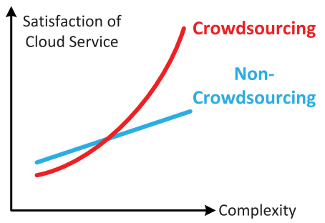

Fig. 2. Crowdsourcing will improve user satisfaction when a correct service is chosen to meet the user’s need, but it will harm satisfaction when it is lack of knowledge that uncertain what action to take with the current environment to supply QoS.

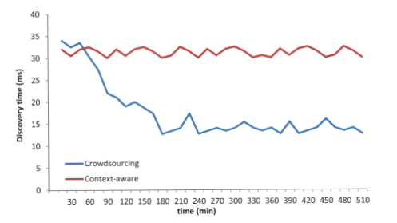

Fig. 3. Service discovery time comparison between two schemes. Num. of User = 50, Mobility = 1 m/s.

Fig 3. Shows the comparison between traditional context-awareness method and crowdsourcing method on service discovery query. The above figure show that our method is more efficient than traditional context-awareness method.

Analysis-

When the crowdsourcing platform gathers enough context data for a location, the service discovering time is reduced rapidly as shown in figure 2. After all the locations’ data were collected, the response time reached a stable level. The nodes using context-awareness method still need to test the quality performance of each cloud service. Thus, the response time could not be reduced.

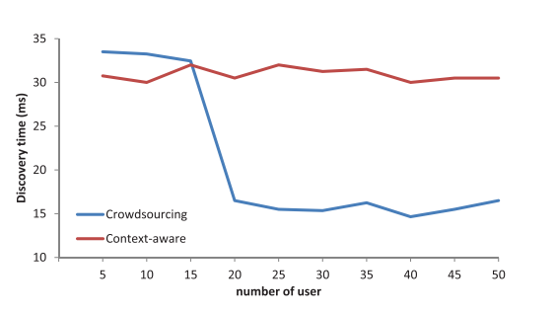

Fig. 4. The impact of number of users on service discovery time when Mobility is 1 m/s.

Comparisons

The simulation results show that the crowdsourcing based awareness method can reduce the cloud service discovery time than the traditional local context awareness method, especially for frequently moving user. The above figure shows that the capability of crowd users is much more than that of single user.

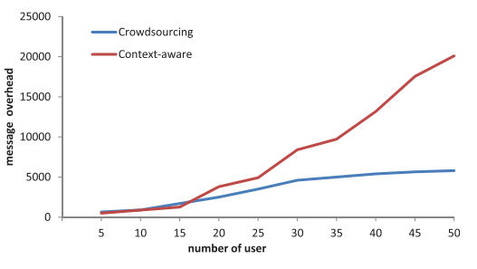

Fig. 5. Network overhead comparison between two schemes. Mobility = 1 m/s.

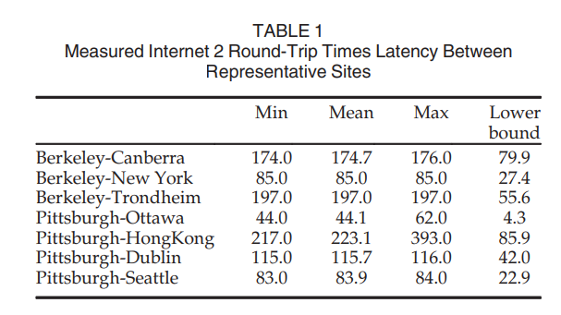

Table 1 shows a measurement result of network latency between different cloud services. We can see that the quality of a cloud service will be significantly different due to the different network environments. Therefore, the service quality of a provider mainly depends on network bandwidth, network latency.

From Table 1, we can see that the quality of a cloud service will be significantly different due to the different network environments. Therefore, the service quality of a provider mainly depends on network bandwidth, network latency. The network bandwidth is influenced by what kind of wireless connection is used, how many people use it, and user’s mobility. So, the service quality is related to multiple context information.

**6 CONCLUSION**

We briefly introduced crowdsourcing based QoS adaptor (CQA), and its key components and QoS control structures. It can be applied to mobile cloud computing environments in order to provide QoS management for cloud service. We presented the system design, together with its implementation. The context parameters associated with the concept are also discussed. We explained how CQA intelligently provides QoS control using context-awareness meth- od’s results. The simulation results show that the crowdsourcing based awareness method can reduce the cloud service discovery time than the traditional local context awareness method, especially for frequently moving user. Current work also denotes that the crowdsourcing model is an efficient way to solve massive parallel task.

Mobile cloud computing promises several benefits such as extra battery life and storage, scalability, and reliability. However, there are still challenges that must be addressed in order to enable the ubiquitous deployment and adoption of mobile cloud computing. Some of these challenges include security, privacy and trust, bandwidth and data transfer, data management and synchronization, energy efficiency, and heterogeneity. We present a thorough overview of mobile cloud computing and differentiate it from traditional cloud computing. Also presented here is a generic architecture that evaluates 30 recently proposed mobile cloud computing research architectures (i.e., published since 2010). This is achieved by utilizing a set of assessment criteria.

In the present era, the number of mobile phones and mobile users is increasing rapidly. The wide usage of mobile devices has brought the concept of cloud computing in limelight. The term mobile cloud computing is a process of integrating cloud computing within the mobile environment. Further, it combats potential challenges such as security, performance, application challenges, and related issues.

It is obvious to know the concept of cloud computing for the people, who have been a part of the industry from quite a long time. But, it is not that natural for the application novice or beginners. They feel puzzled with so many technical words that revolve around mobile computing and mobile cloud applications.

Mobile cloud allows application developers to design apps, particularly for mobile users. And, the users can use these apps irrespective of the device operating system or storage capacity. In the mobile cloud, data storage and processing are executed out of the mobile device.

With a Western-centric view of the world, it can sometimes be hard to remember that not everyone owns a smartphone. There are still a large number of markets worldwide where the dominant phone is a feature phone. While it’s true that smartphones will grow in percentage and feature phones will become more sophisticated in time, these lower-end phones are not going away anytime soon. And it’s their very existence which will help drive the mobile cloud computing trend.

Not only is there a broader audience using feature phones in the world, there are also more web developers capable of building mobile web applications than there are developers for any other type of mobile device. Those factors, combined with the fact that feature phones themselves are becoming more capable with smarter built-in web browsers (and more alternative browsers available for download), will have an impact on mobile cloud computing’s growth.

There are two primary reasons why ABI believes cloud computing will become a disruptive force in the mobile world. The first is simply the number of users the technology has the power to reach: far more than the number of smartphone users alone. The second reason has to do with how applications are distributed today. Currently, mobile applications are tied to a carrier. If you want an iPhone app, for example, you have to first have a relationship with the mobile operator who carries the iPhone. If you want a Blackberry app, the same rule applies. But with mobile clouding computing applications, as long as you have access to the web, you have access to the mobile applications.

**7 REFERENCES**

1. N. Fernando, S. W. Loke, and W. Rahayu, “Mobile cloud computing: A survey,” Future Gener. Comp. Syst., vol. 29, no. 1, pp. 84–106, 2013.
2. Y. Liu, J. Wu, Z. Zhang, and K. Xu, “Research achievements on the new generation internet architecture and protocols,” Sci. China Inform. Sci., vol. 56, no. 11, pp. 1–25, 2013.
3. Y. Zhao and Q. Zhu, “Evaluation on crowdsourcing research: Current status and future direction,” Inform. Syst. Frontiers, vol. 16, no. 3, pp. 417–434, 2014.
4. D. Yao, C. Yu, H. Jin, and J. Zhou, “Energy efficient task scheduling in mobile cloud computing,” in Proc. 10th IFIP Int. Conf. Netw. Parallel Comput., Sep. 19–21, 2013, pp. 344– 355.
5. Using Crowdsourcing to Provide QoS for Mobile Cloud Computing Dezhong Yao, Student Member, IEEE, Chen Yu, Member, IEEE, Laurence T. Yang , Senior Member, IEEE, and Hai Jin , Senior Member, IEEE.
6. Exploiting Mobile Crowdsourcing for Pervasive Cloud Services: Challenges and Solutions Ju Ren, Yaoxue Zhang, Kuan Zhang, and Xuemin (Sherman) Shen.